07-06-2021

ABHINAV RANJAN

RA1911003010003

CSE A1 SECTION

SRMIST , KTR

CC UNIVERSITY PRACTICALS

Q. Consider a company consisting of 3 departments. Each department has a minimum of 3 hosts. Now assume yourself as a network administrator having the IP address 192.168.10.0/27. Create the required amount of subnets and configure the network for the departments using Static Routing. Use the ping command and test the reachability between nodes.

SOLUTION :

AIM :

To configure a network for the 3 departments of a company(3 hosts each) using static routing.

PROCEDURE :

There is /27 which means that there are 3 extended bits.

So 2 power 3 = 8 subnets are possible . Also , 2 power 5 =32 is the number of hosts possible.

/27 means the last octet binary would have

11100000

So , the subnet mask would be 128+64+32 = 224

So the subnet mask is 255.255.255.224.

Since 3 hosts are possible for each department and there are 3 departments , I will use 7 hosts in 7 different subnets (7 different usable host range) and 2 more hosts in another subnet. (Total 8 subnets and 8 host ranges).

The starting address would be 192.168.10.0 and the ending address would be 192.168.10.255. There are 8 usable host ranges and each range is of size 32 (2 power 5).

For example , the first range has the network address as 192.168.10.0 and the usable range is 192.168.10.1 - 192.168.10.30 and the broadcast address is 192.168.10.31. The other ranges have been given in the tabulation.

TABULATION FOR SUBNETTING :

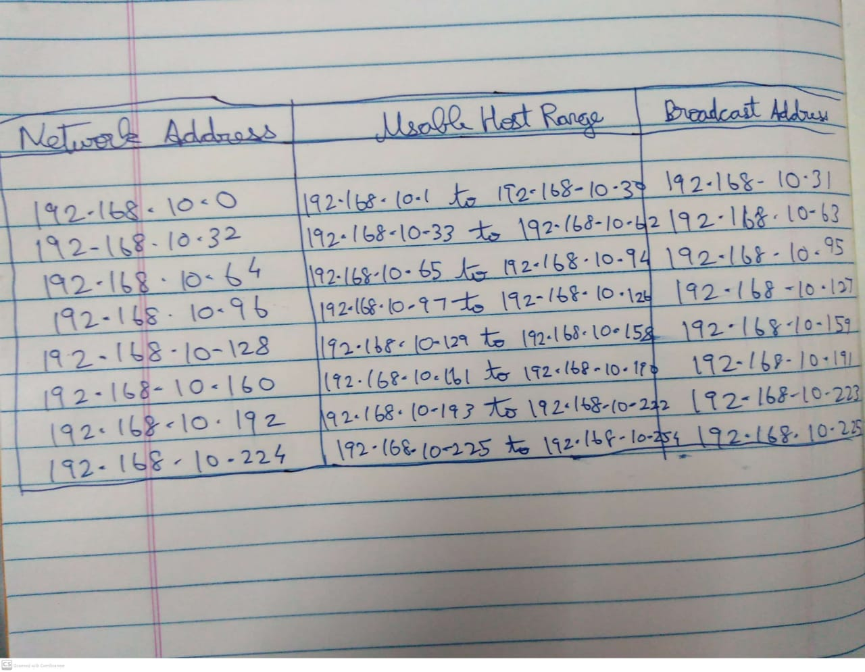

OBSERVATION AND SCREENSHOTS :

1. Main page

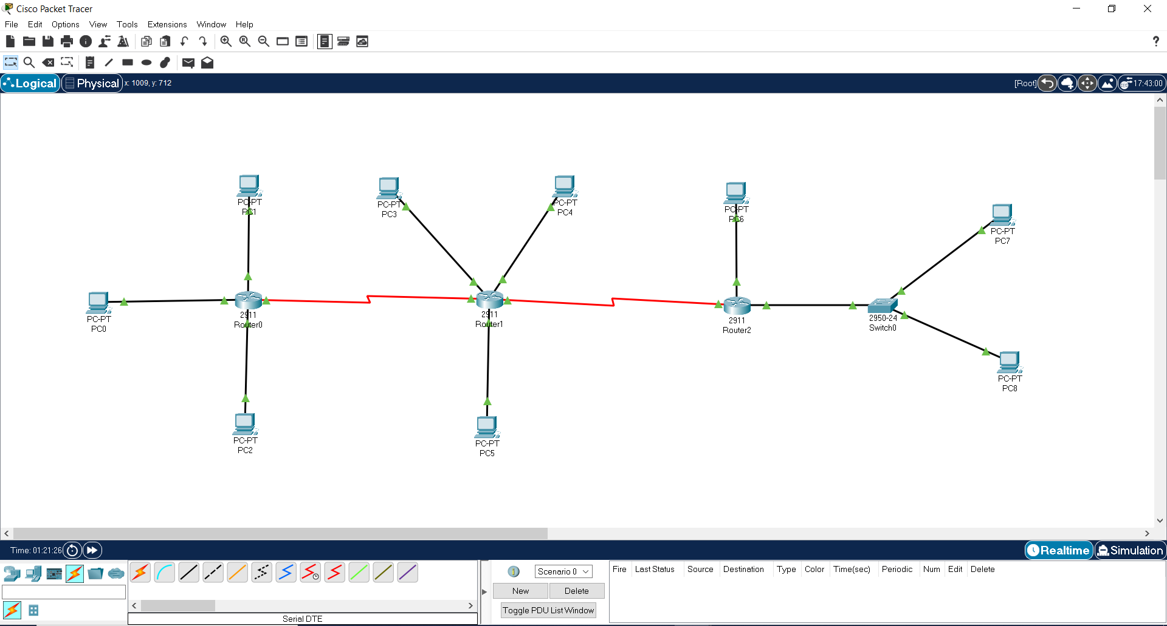

1. Router 0 static

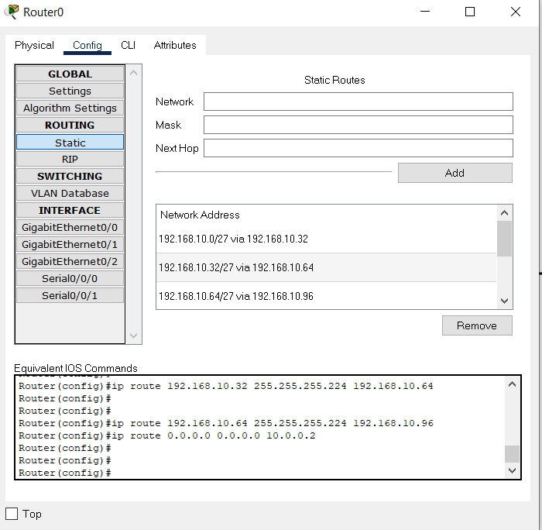

1. Router 1 static

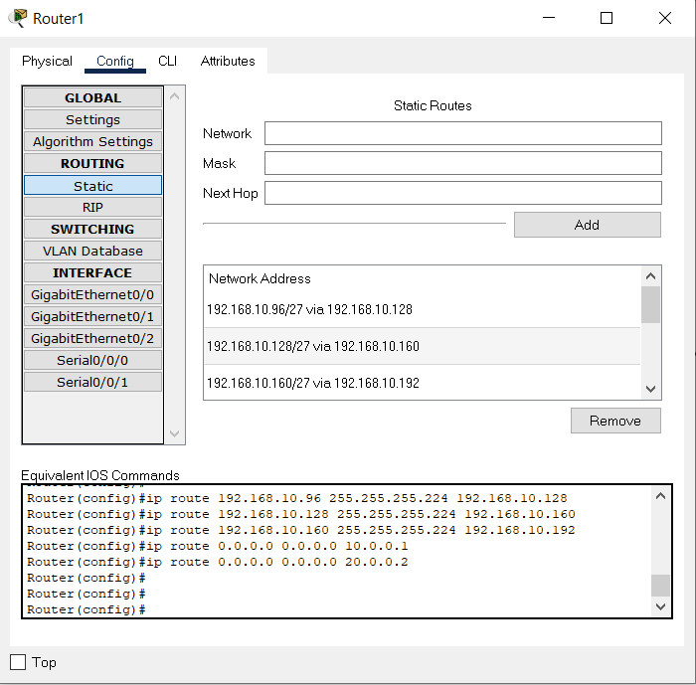

1. Router 2 static

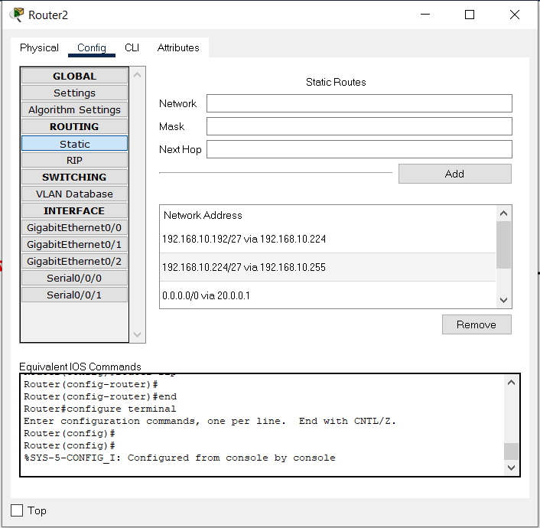

1. For each pc , its ip address is in a separate usable host range . Here is one sample for PC 0 ip address

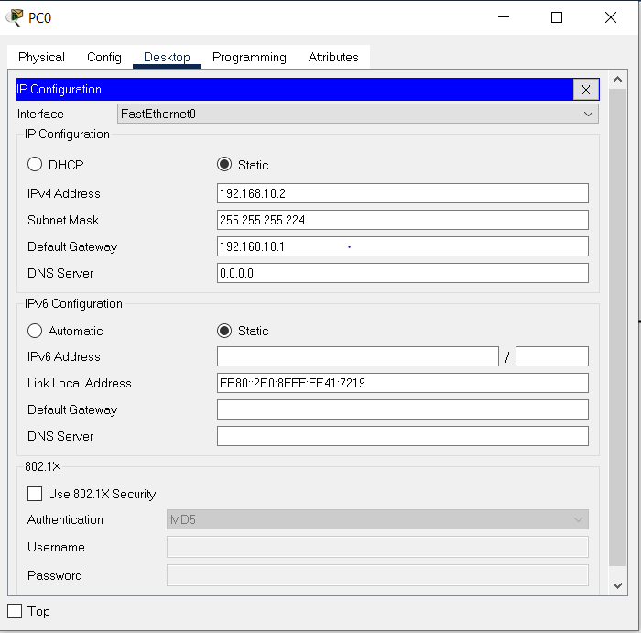

1. PC 0 pinging PC 1 and PC 8 - connection successful and reply is coming

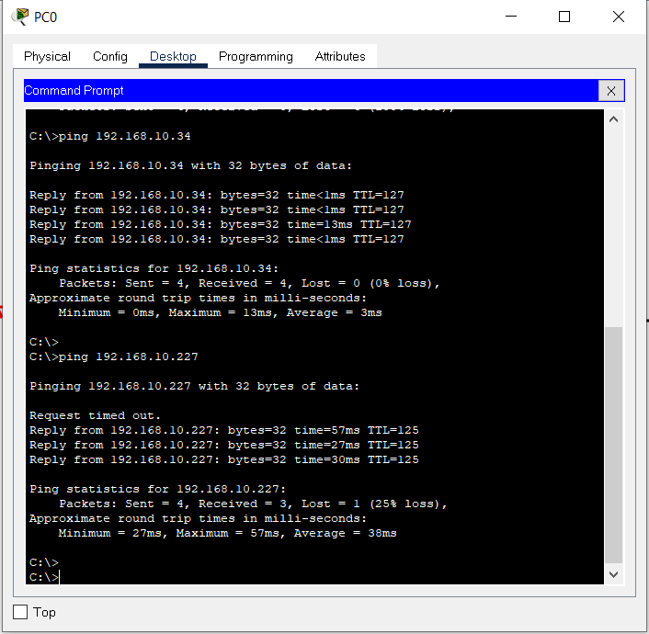

RESULT :

Thus we have established a connection between department networks using static routing